Cloning the Application Repository
First, the project repository is cloned from GitHub.
git clone https://github.com/devivaraprasadgannavarapu/movie-analyzer.git
Navigate to the project directory
cd movie-analyzer
- Frontend Installation and Setup
The frontend application contains a package.json file which defines the Node.js dependencies required to run the frontend.
To run the frontend application, Node.js and npm must be installed.
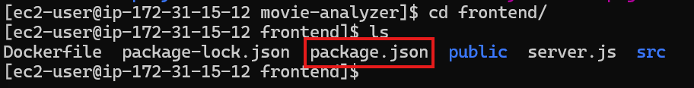
Install NVM (Node Version Manager)
curl -o- https://raw.githubusercontent.com/nvm-sh/nvm/master/install.sh | bash
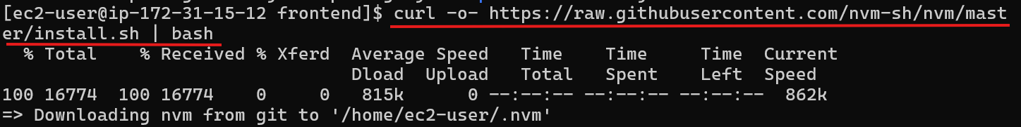
This command downloads and installs NVM, which is used to manage different Node.js versions.
Reload the shell configuration
source ~/.bashrc
This command reloads the shell configuration so the nvm command becomes available.
Install Frontend Dependencies
Navigate to the frontend directory.
cd frontend

Install project dependencies.
npm install package.json
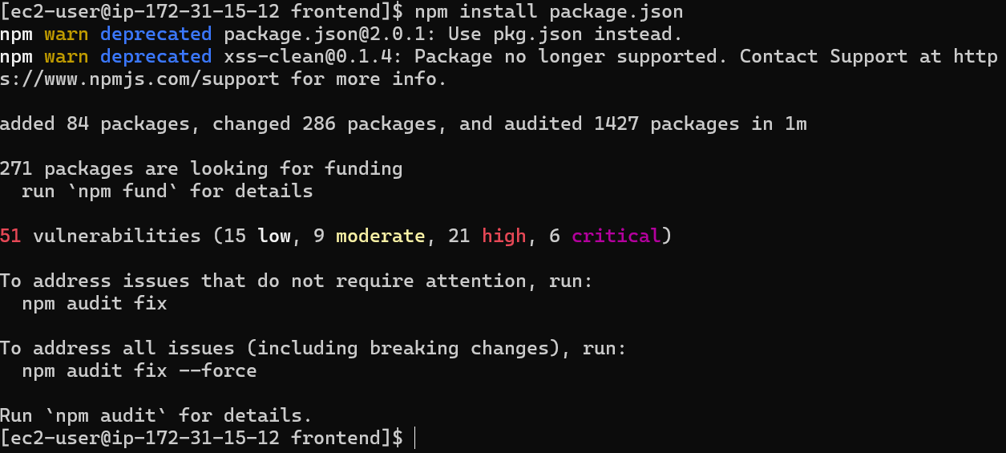
- npm install reads the package.json file.
- It downloads and installs all required Node.js libraries.
Running the Frontend Application
Start the frontend server using:
node server.js (or) npm start
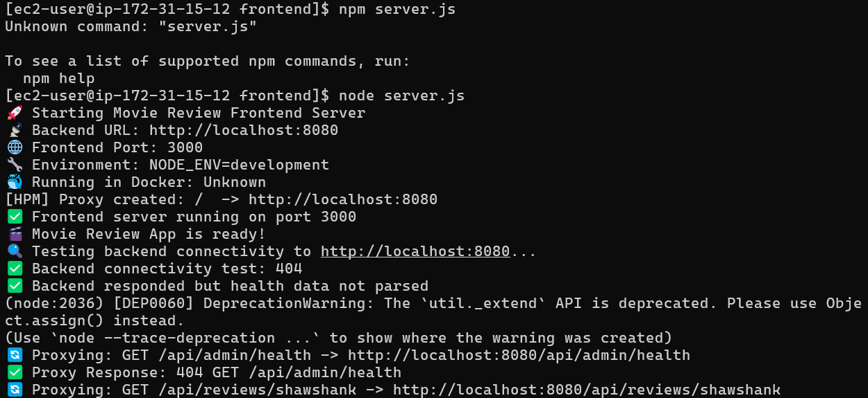
Try :- http:// 34.201.28.53:3000
The frontend server starts on port 3000 and provides the user interface for the movie analyzer application.
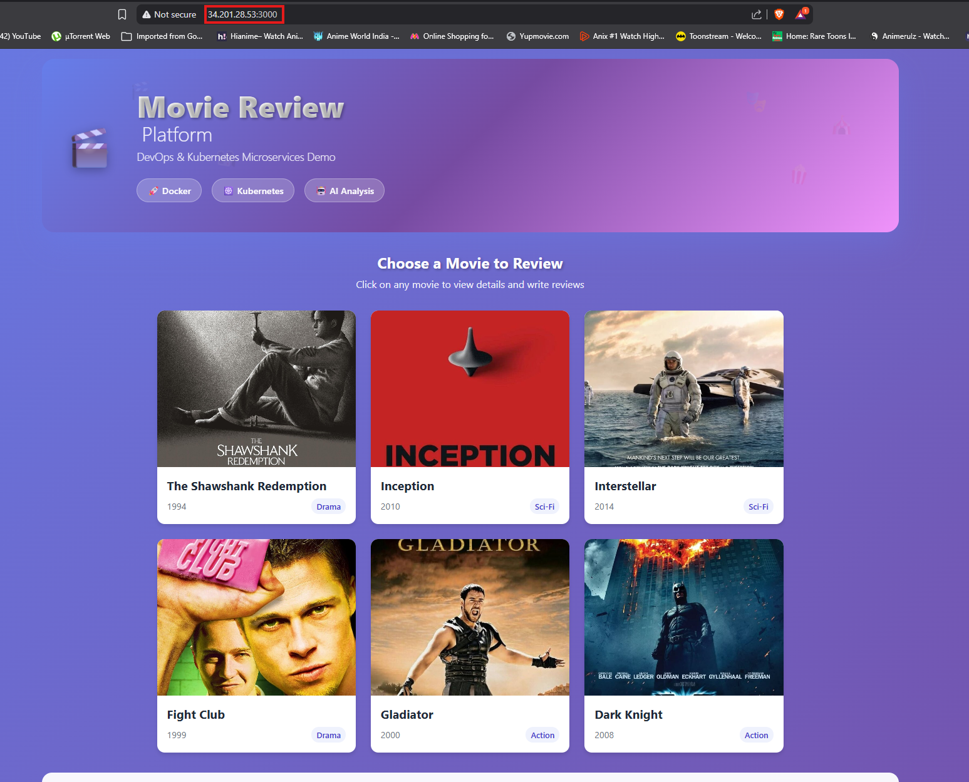
- Backend Installation and Setup
The backend application is a Java Spring Boot application built using Maven.
Navigate to backend directory
cd ../backend
Build the application using Maven
mvn install
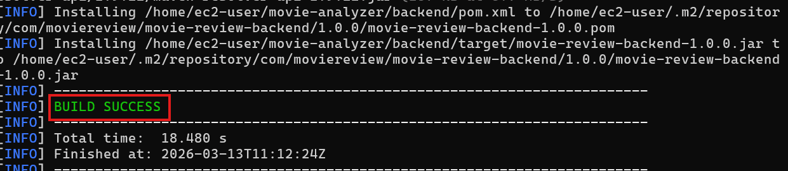
- Maven reads the pom.xml file.
- Downloads required dependencies.
- Compiles the Java code.
- Generates the JAR file inside the target directory.
Generated file:
target/movie-review-backend-1.0.0.jar

Run the Backend Application
java -jar target/movie-review-backend-1.0.0.jar
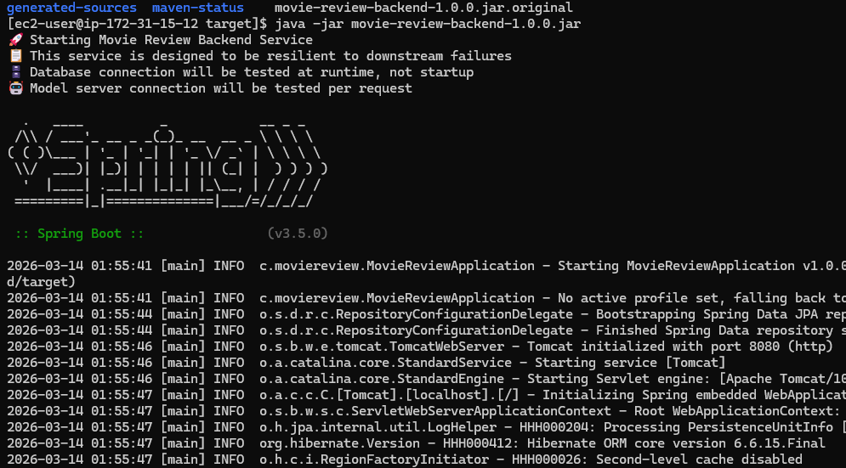
- java -jar runs the compiled backend application.
- The backend server runs on port 8080.

- Model Service Setup (Python)
The application also contains a Python-based sentiment analysis model.
Navigate to the model directory
cd ../model
Create Python Virtual Environment
python -m venv myenv
This command creates an isolated Python environment for the project.
Activate Virtual Environment
source myenv/bin/activate
Activates the virtual environment so that Python packages are installed only for this project.
Install Python Dependencies
pip install -r requirements.txt
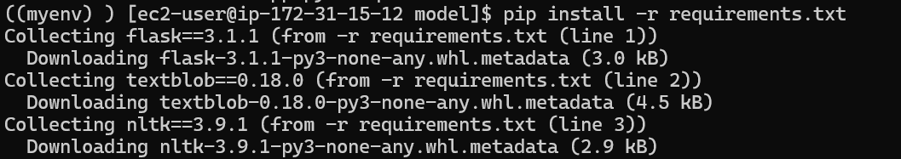
This installs all Python libraries required for the model service.
Running the Python Model Service
Start the model server:
python app.py
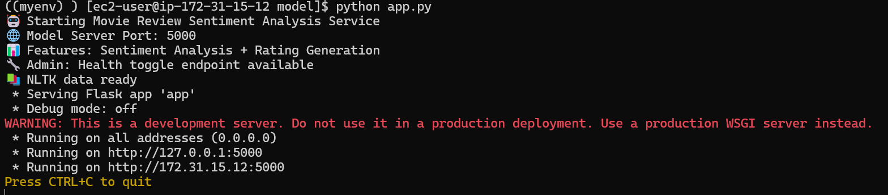
- This starts a Flask server.
- The service runs on port 5000.
- It performs sentiment analysis on movie reviews.
